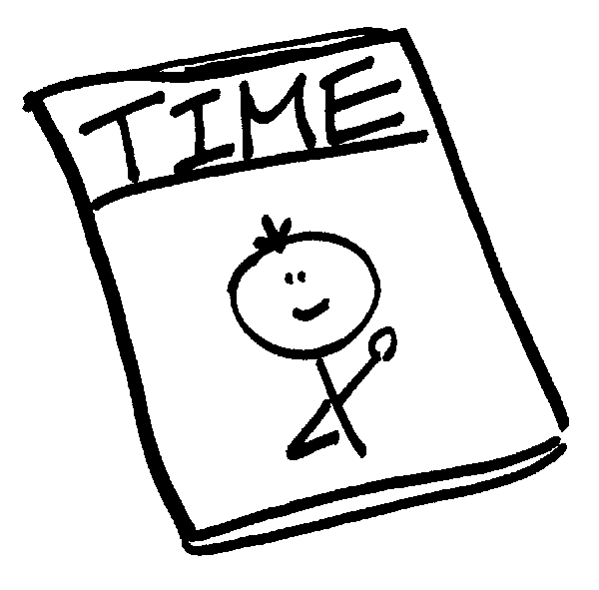
2nd Quarter Third Grade Project

Due Date: January 20, 2016

Directions: You will be creating and designing your own magazine for our second quarter project. Since our first quarter project was connected to social studies, we wanted to focus this project on our nonfiction reading and writing units. You will come up with a magazine name and design a cover for your magazine. You will also complete a table of contents for your magazine that outlines everything you will find inside. You will only be responsible for writing two informational articles inside the magazine that includes specific text features. You will be using 8x11” colored or white paper for your project. You should bring it in all put together. Below are more specific requirements:\

Magazine Cover (hand written or typed)…
Must Include:
- Magazine title is neat, enlarged, bolded, and located on the cover.
- Title is creative and reflects the content that will appear inside the magazine (For example, in a National Geographic Magazine I know I will find articles related to science and not shopping).
- Cover includes a large, detailed, and colorful illustration that goes along with the article they wrote
- Cover includes a picture caption for that picture
- Cover includes other text that highlights other things you will read about inside the magazine. You may choose to include additional smaller pictures on your cover other than your large picture if you would like.
Research…
- You must conduct research and take notes as you are researching about 2 different topics that both relate to your magazine title. Examples of topics could include sports, animals, fashion, space etc. You will need to hand in your research. Your research should be organized. You should bullet or number and include headings/titles. You should be keeping track of every website you get research from for your bibliography page.
Text Structure…
- Text structure is the way a writing piece is organized. Both of your articles must include two of the following text structures: cause/effect, problem/solution, sequence (chronological order), compare/contrast, or description. You must choose two different ways to organize your articles.
Two Informational Articles (hand written or typed)…
Each of your 2 Articles Must Include:
- Catchy, enlarged, and bolded heading (title) at the top of your article
- At least 4 paragraphs with a bolded subheading above each paragraph. Each paragraph should include at least 4 sentences.
- At least 4 highlighted and bolded words important vocabulary words that will be found in your glossary
- At least 1 detailed and colorful picture with a picture caption
- At least one of the following text features: text box, diagram, map, graph, timeline, sidebar
- A catchy and interesting introductory paragraph as the first paragraph of the article
- A concluding paragraph as the last paragraph in the article
Magazine Quiz (hand written or typed)…
- You must create a 10 question quiz for your magazine that could be answered by a reader from the information you have included in your magazine. You decide how you want to set up your quiz and what types of questions you want to ask. You may do true/false, multiple choice, short response. It is up to you if you want to include fun activities as part of your quiz such as a crossword puzzle or word search.
Glossary (hand written or typed)…
- At the end of your magazine should be a glossary. You should title it “Glossary” and include all bolded and highlighted words in alphabetical order with their definitions. You should have at least 8 words in your glossary (4 from each article).
Bibliography (hand written or typed) that Includes…
- All online and paper sources used for research and articles are includes.
- This is on a separate page.
- It is neat and organized.

You may put together your magazine however you would like. For example: staple it, use string, put in protective covers, use a report cover, laminate etc. Your magazine should be the size of an actual magazine so 8x11” paper would work best. You may use white paper or colored paper. If your child chooses to handwrite their article, your teacher has paper with lined printed on it and boxes for text features so it will keep their article organized. Have them request this paper from their teacher. The teacher will then either send it home or e-mail it. There will be no presentations for this project. We will be doing some type of gallery walk in class to share our magazines.

The order of your magazine should be put together in this order:
- Magazine Cover
- Article 1 (may be 1-2 pages)
- Article 2 (may be 1-2 pages)
- Magazine Quiz
- Glossary
- Bibliography

2nd Quarter Third Grade Project Rubric
Due Date: January 20, 2016
Student Name: _________________________
Criteria | Points
Magazine Cover  - Magazine title is neat, enlarged, bolded, and located on the cover.  - Title is creative and reflects the content that will appear inside the magazine.  - Cover includes a large, detailed, and colorful illustration that goes along with the article they wrote.  - Cover includes a picture caption for that picture.  - Cover includes other text that highlights other things you will read about inside the magazine. | /15
Research  - Research is detailed and complete for both articles.  - Research is organized. | /10
Text Structure  - Both articles include two of the following text structures: cause/effect, problem/solution, sequence (chronological order), compare/contrast, or description. Two different ways are used to organize the articles. | /10
Two Informational Articles  Each article includes:  - Catchy, enlarged, and bolded heading (title) at the top of your article  - At least 4 paragraphs with a bolded subheading above each paragraph. Each paragraph should include at least 4 sentences.  - At least 4 highlighted and bolded words important vocabulary words that will be found in your glossary  - At least 1 detailed and colorful picture with a picture caption  - At least one of the following text features: text box, diagram, map, graph, timeline, sidebar  - A catchy and interesting introductory paragraph as the first paragraph of the article  - A concluding paragraph as the last paragraph in the article | /40
Magazine Quiz  - Magazine includes a 10 question quiz that could be answered by a reader from the information included in the magazine. | /10
Glossary  - At the end of the magazine a glossary is included. It is titled “Glossary” and includes all bolded and highlighted words in alphabetical order with their definitions. There are least 8 words in the glossary (4 from each article). | /10
Bibliography  - All sources that were used throughout the article are cited.  - It is on a separate sheet of paper.  - It is neat and organized. | /5
WOW FACTOR – Project is exceptional and goes above and beyond requirements (5 points) | /5 BONUS POINTS
Final Grade: ___________ /100%

